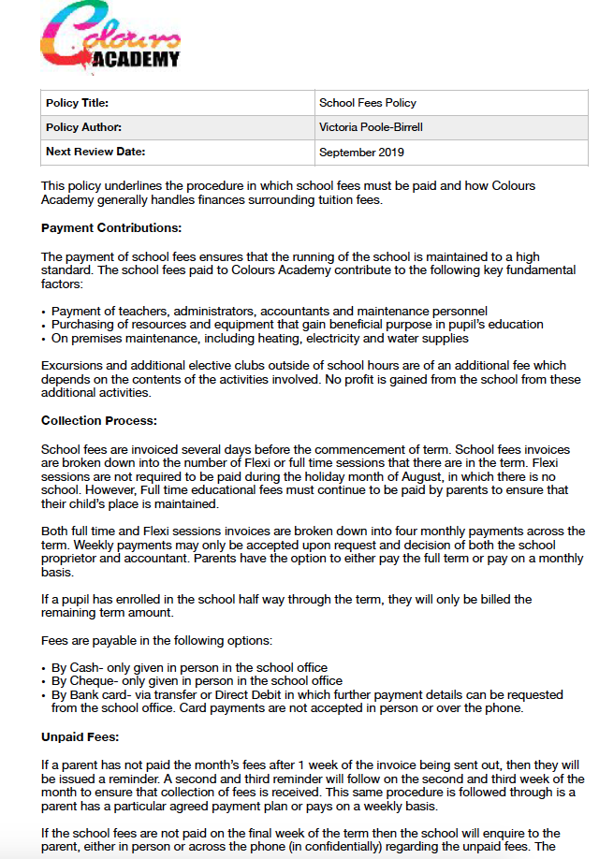
Deposits for reserved places:

Parents wishing to reserve a school place must pay a deposit of either;

- £200.00 per pupil under their care for a place that schedules attendance of 3 or less days (or sessions equating to this amount)
- £500.00 per pupil under their care for a place that schedules attendance for 4 or more days (otherwise known as a full time place)

Deposits are due on the first day back from the summer holiday before the commencing academic term of the start year. It should be made aware of that the place will not be permanently secured until the deposit (or alternatively known as reservation fee) is paid; the school recommends that the relevant fees are paid as soon as they are invoiced. The school does not take any responsibility for securing places until the above deposit is paid. Stating a date in which the fees can be paid is not an acceptable means of appropriately securing a place.

Exclusion and Suspension Continuation payments:

If a child is suspended or excluded for a period of time, parents/legal guardians must continue to pay their fees until the end of the month of exclusion. This point specifically applies to permanent exclusion; for example, if a pupil’s education was terminated permanently on the the 8th of the month and their payment was due on the 19th, this payment will still have to be made. Fees should be continued to pay over the suspension period to further enable the child’s place to remain open. Exclusion of either of the above sorts, is not an acceptable reason for the school to refund fees and the school does not refund fees in any excluding situation.

Other scenarios in which school fees are non-refundable also include;

- If a pupil was going on a school excursion but no is, due to an injury, family or personal emergency or other known reason
- If a parent is not satisfied with the general education of their son/daughter
- If the child was not satisfied with the provision of after school clubs and activities
- If a parent has reserved a place and the pupil is no longer going to attend the school on the start date of education
- If the pupil has had an injury and is missing a period of the term
- If the pupil is going on holiday and is missing a period of the term
- If the pupil is not attending school on a regular basis under schedules written into the DFE’s Advice and Guidance on Attendance for schools and they still formally on the Admission Register
- If a pupil decided to change days, sessions or in school activities
- If a pupil is not satisfied with the outcome of a anticipated grade or work goal
- If parents are not satisfied with the handling of a Safeguarding incident, behaviour or bullying incident or dealing of complaint
- If a parent is not satisfied with the curriculum that the school offers
- If a child suffer from an injury on the school premises or catches a passing virus
- If a child shows little progression or development of skillset since the beginning of their education their
- If the parent feels uncomfortable and unsatisfied by the school environment, assets and staff
- If the pupil’s lack of progress results in them having to fund an external tutor/ mentor (In which the school are not responsible for paying for)
- If the pupil’s travel to the school is cancelled or if the carers of the child experience travel issues

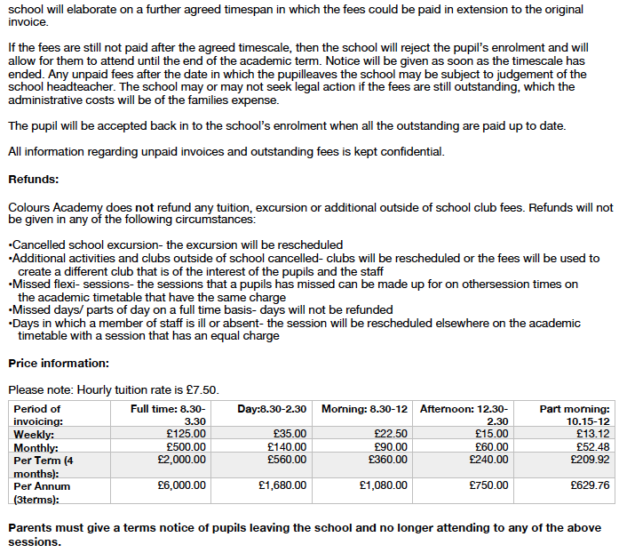
This policy is updated on a yearly basis. Reviewed November 2020.

