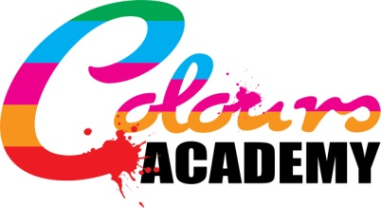

Next Review Date: February 2022

Colours Academy Complaints Procedure

Colours Academy is willing to deal with complaints to the school that are addressed in an informal or formal manner. Colours Academy will follow a step by step procedure to ensure that the complainant is satisfied with the outcome of the procedure.

The school will ensure that this publication is made available for parents via request and through information on the school website. This procedure is to be reviewed on a yearly basis.

There are three stages in which the complaints procedure can be handled to see the appropriate positive outcome for the parent of the pupil, the pupil and all parties concerned;

- Informal
- Formal
- Hearing before a panel, including an independent panel member

Timescales for managing a complaint:

Timescales for handling any sort of complaint should be no longer that 3 working days from the date the complaint is addressed and to the point the resolution is informed to the parent. If a hearing panel needs to be formed, the headteacher should inform the complainant of a more accurate timescale including a date of the hearing.

Informal Complaints:

Parents can and are given the opportunity to address a complaint on an informal basis by arranging to talk to the headteacher or another member of school staff. Parents are open to talk to parents at the beginning and at the end of the school day if the complaint is minor and can be simply resolved.

Formal Complaints:

If the parent is not satisfied with the eventual outcome of the informal complaint outcome, then they then have the further option to write formally about the complaint, their response to the initial complaint procedure and why they were not satisfied with the outcome. Any formal complaints should be addressed to whoever it regards in terms of staff, otherwise the matter can be handled by the headteacher.

Panel organised complaints:

If the complainant is not satisfied either with the outcome of the informal or formal complaint handling methods, then they have the option to resubmit their complaint. Staff, in this third stage of handling the complaint, must arrange a panel hearing with a panel appointed by the school proprietor which must include at least three individuals who were not involved in the matters detailed in the complaint.

At least one of the panel members must be independent to the running or management of the school. The parent must be allowed to attend the panel hearing if they wish, but it is not mandatory if they do not want to attend.

The panel must record notes of their findings and further recommendations to support the details of the complaint. A copy of any notes and recommendations made must be made available to the complainant and on occasion the person who is being complained about. The notes and recommendations made must be made available to the school headteacher for review.

Making a record of complaints:

All complaints made must be appropriately filed in a record of complaints and kept on record in case they need to be referred to again (No matter how the complaint was handled) The record of complaints must present the actions taken by the school as a result of the complaints to demonstrate further development of the school community and wellbeing. All records of complaints must be kept confidential unless an inspecting body asks to see them.

This procedure is to be referred to by staff who wish to understand more about handling a complaint.

