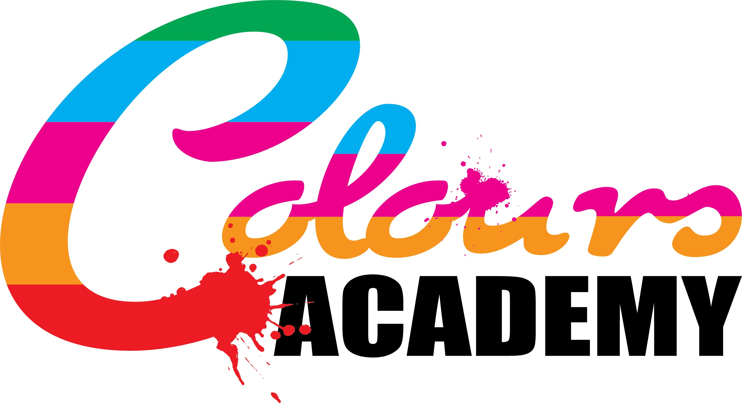
Policy Title: | Behaviour Policy
Policy Author: | Victoria Poole-Birrell
Next review Date: | September 2021
See Page 6 for Annex A and B (Types of Sanctions and Rewards System)
The ‘Colours Academy Behaviour Policy’ underlines the rules, restrictions, behaviour guidelines and responsibilities of the students, pupils and staff at Colours Academy. This policy is to be referred to if any member of academy staff requires further information/ further education towards the school rules and student/staff behaviour guidelines. All members of school staff must have a consistent approach with regards to how they handle the behaviour of pupils.

The behavioural standards set out in this policy should be reminded of and reviewed in staff training and inset days.

This policy must be made available to parents upon request. Behaviour procedures at Colours Academy should be fully explained to parents when pupils have been issued warnings or detentions. This includes details regarding rewards and sanctions.

Members of staff that should refer to this policy are;

- School teaching staff
- The headteacher

Colours Academy aims to promote the following areas in accordance to regulating behaviour;

- Good Behaviour
- Self Discipline
- Respect of peers and school staff and teachers
- Prevention of bullying
- The completion of assigned work of pupils, of both at school and at home (homework)
- Excellent supervision of pupil’s behaviour
- Good discipline outside of school on excursion and in the eye of the public
- Control of classroom management, free of disruptions and intolerable behaviour

Clothing:

Staff must be dressed in presentable clothing that could clearly set an example to the students and pupils at the school. Pupils are permitted to wear whatever they wish (non-uniform), however must still dress sensibly and appropriately and must consider the activities that they will be involved in and the weather conditions. Pupils must be advised to wear an appropriate order of dress for more physical activities (outdoor and indoor) Students, pupils and members of academy staff must be advised to reconsider their attire if their chosen attire is currently not appropriate.

Main Behaviour Standards:

It is expected that the students and pupils at Colours Academy are constantly well mannered towards their peers and members of academy staff. Pupils are expected to maintain a sensible and responsible level of tolerated behaviour on the school premises, and can also act in a behaved manner around members of staff, peers and around the public during excursions and visits. Pupils must ensure that they are always considerate around everyone member of staff and other pupils, for example not making disturbance around pupils working and students under examination conditions. Pupils and students must be respectful towards their peers and teachers and must obey all reasonable requests given to them. The academy will not tolerate any:
- Foul language (such as swearing)
- Racist comments
- Bullying of pupils and staff (mental or physical)
- Comments against ones beliefs and religion
- Spitting
- Unkind and harmful comments
- Fighting
- Rude finger signs
Members of academy staff must supervise and maintain a high level of observation to prevent any of the above from happening or being provoked.School staff must refer to the local authority/ district council when a behavioural issue is significantly relating to any safeguarding problems that have been previously recorded. If the pupil’s behaviour shows signs of criminal offence, or implies that they have committed a criminal offence (at home or at school) teachers must refer to the local policing authority.

1:1 support for misbehaving pupils:

1:1 pupil support must be reviewed where necessary for pupils who are found to be consistently breaking school rules and behavioural standards. 1:1 pupil support aims to;

- Break down any problems that influence or provokethe pupil’s bad behaviour
- Discuss what impacts the pupil’s behaviour has on the school community and on peers and members of staff
- Discuss how to improve their behaviour

Teachers have an ultimate power of taking control of the behaviour of pupils. Teachers also have the authority to discipline pupils outside of school, this includes on excursions and pupils on sports fixtures. Attention must be made by teachers in assemblies, to explain how behavioural standards must be improved.

Parents must be informed about pupil’s bad behaviour after warnings, detentions and in pupil reports.

The school should consider and review if the bad behaviour of a pupil is significantly due to any safeguarding reason. Teachers must collectively determine whether poor/ disruptive behaviour is a result of unmet educational needs or home related issue. In such cases, teachers must refer to the schools safeguarding policy and must complete a behavioural assessment (if necessary to do so)
Forbidden Items:

Certain items are forbidden on entry to Colours Academy via a pupil, student or member of staff. Alcohol is strictly banned from everyone on the school premises.. However, the science department may take alcohol into school providing that they monitor the use of it in lessons and ensure that it is locked away from access. Drugs are strictly forbidden from Colours Academy, unless a member of staff or pupil is on certain medication and requires a daily intake of a certain prescribed drug. The allowance of a pupil bringing in medical drugs on the school premises requires completion of a medical form. Any medically prescribed drugs entering the academy must be contained until they need to be used and must be supervised during the consumption process. Any cigarettes, lighters, matches, knives, chewing gum and personal stereos are all strictly forbidden without any exception.

Members of teaching staff, including the head teacher have authority to search pupils, including use of any reasonable force, to prevent the usage of these forbidden items. Teachers have the authority to confiscate items and return them to the pupil, only if they are safe. Items such as the listed forbidden items above should not be returned after confiscation and teachers should contact the local policing authority on finding such objects.

Mobile phones may only be used in conjunction to research and photography related activities. External calls may only be made with permission from a member of staff and supervision during the call.

Graffiti and litter is strongly not permitted. Members of staff must inform pupils to use bins and other areas of waste disposal.

There must be no running in the academy at any time, unless members of academy staff and pupils are undertaking a physical activity that involves fast-paced movement.

Premises restrictions and use of equipment:

No academy equipment may be used without the permission of a member of department staff. Staff who are do not work in their usual department and area of teaching, are not permitted to given permission to pupils to use equipment that they may not be qualified enough to know about.

Pupils must not enter or leave the academy without permission of a member of academy staff. Pupils are not permitted to enter an academy facility that may contain hazardous equipment and substances without the permission and supervision of a member of staff. Any pupil(s) entering a facility, breaking an entry, exiting school premises without permission and using equipment without permission must be given a warning/ necessary sanction.

Pupils must be made aware of the circumstances that involve a teacher not being present and what they must do and the dangers of using school equipment without the permission of a teacher. Pupils must be made aware of using school technologies appropriately. Pupils who develop a consistent record of bad behaviour will be excluded from using technology privileges at school.

Transitions:

Pupils must be aware of the importance of swift transitions between lessons and the warning they may be issued if they are late to a lesson. A collective number of times in which a pupil is late means that they are issued a detention in reflection to their absences, especially if the excuse for being late is unreasonable or is a result of bad behaviour between classes.

Sanction systems:

As aschool, we expect pupils to respect our set rules.If a pupil crosses an academy rule boundary or owns an intolerable attitude towards their behaviour, theywill be warned three times of a punishment through addition of a strike to a strike tally. If pupils overrun their three strikes, they will be issued a detention where they will use the time to complete any school/ homework or independent study.Student’s behaviour must be monitored closely and recorded to be then further used in pupil assessments and termly reports to parents.

Pupil’s with special educational needs (SEN) should be treated in reference to their individual needs, especially if they hold behavioural issues.

Detentions should be made in accordance to human rights, disability, special educational needs, race or other equality. The detention or punishment that is issued must always be reasonable.

Staff who are voluntary, including parents who have volunteered to help on school trips, do not have the authority to issue a detention or other kind of punishment on a misbehaving pupil. Pupils do not have the authority to issue punishments upon their peers. School trip leaders should be notified of any bad behaviour of pupils.

Detention activities could include:

- Written apologies
- Extra work, or repeating a sentence or line until the teacher is satisfied
- Writing an essay of a topic chosen by the teacher
- Loss of privileges, including being excluded from school trips and sports fixtures
- Missing break time
- School based community service

Lunchtime detentions should allow time for the pupil to eat, drink and use the toilet. Detentions that involve isolation should also allow the pupil enough time to eat, drink and use the toilet, should be reasonable and should be for a limited time that is no longer that 15 minutes.

Temporary or permanent exclusion should be considered collectively by members of staff and the head teacher if a pupil’s behaviour is of an extreme level. This may include posing serious threat, or causing harm to pupils and members of staff. Temporary exclusion may last as long as 1-4 weeks, or until the following academic term.

Pupils under the age of 18 are subject to being issued a detention if they own poor, intolerable or unsustainable level of behaviour.Pupils breaking school rules are to be issued a warning, detention, temporary or permeant exclusions without parental consent. Parents however, have a right to discuss permeant exclusions with the head teacher.

Pupils being punished outside of school includes;

- On school excursions
- Travelling to and from school
- When a member of the public has made a complaint on identifying a member of the school
- When pupils miss days off school for an unauthorised reason
- When pupils affect the school’s reputation

Pupils posing dangerous threat to pupils or possessing a behaviour that is uncontrollable, must be sent home until members of school staff and headteacher have collectively confirmed what to do, concerning the pupil’s behaviour.

Using force or other physical restriction should be only used in the following situations;

- Conducting an emergency search for forbidden items
- In the situation where the pupil is causing serious damage to school property
- When the pupil is posing a serious harmful threat to other pupils and members of school staff
- When the pupil is attempting to self-harm

Reward systems:

Good deeds, behaviour and work produced by pupils and students will be rewarded a point towards their house. Good behaviour will be noted in reflections and in annual reports to parents. Reflective awards and certificates are dedicated to pupils who have shown good progress, excellent effort and determination. All pupils awards will be unique and fitted to the educational achievements of the individual.All rewards must be fair and must vary in relation to the age of the pupil.

The headteacher must include details about improvements made to the school’s behavioural standards in the end of year school evaluation. This must be published to the school website and must be publicised to the attention of parents.

Consistent teaching of good school behaviour must be taught in assemblies, in topics in lessons such as Physical Social Health Education and must be reminded of good behaviour in all lessons after warnings and detention reminders.

This policy is to be reviewed annually

Victoria Poole-Birrell
-Head Teacher

Annex A – Sanctions (New system adopted 18/03/2020)

This is a new system updated 18/03/2020. The following guidelines specify that, if pupil’s break any of the following rules they are to be given the appropriate categorised sanction. If the pupil refuses to complete the sanction they will be given a Formal Warning. 3 Formal warnings equal a Temporary Exclusion of 3 school days or other specified duration which the headteacher feels appropriate. 3 Formal warnings after the Temporary exclusion will heavily affect the decision of a Permanent Exclusion.

Staff should have a focus and attitude towards the above system which is strict, formal and robust in affect. Pupils should be warned of the consequences of their actions in order to create a strong disciplinary standard throughout the school community. All sanctions given should be reasonable and should follow the guideline set below.

There are 5 types of sanction in this system. If pupils do not complete the sanctions listed B-E (Not A) Then they are subject to an exclusion (etc)

A – Verbal Reprimands
A verbal reprimand should be given if the pupil;
- Swears (once)
- Uses Rude finger signs or gestures (Once)
- Has their phone out (once)
- Back Chats teachers or are rude and/or sarcastic (once)
- Is running inside (once)
- If the pupil is 5-10 minutes late for the lesson
B – Completing Extra work at home
Pupils should be issued extra work to do at home if the pupil;
- Does not complete work in lesson as a result of other bad behaviour
- Does not complete homework for an acceptable reason
- Does not complete work to an expected standard in line with the pupil’s abilities
C – School Based Community Service (eg; cleaning and tidying classrooms, washing up etc)
Pupils should participate in the above if they;
- Repeatedly bully another pupil or member of staff
- Are found with any forbidden items on the school’s behaviour policy
- Commit to graffiti on the school’s property
- Litter
D – Writing lines or an essay
Pupils should complete the following sanctions if they;
- Say racist comments
- Say comments which are offensive and/or against ones belief or religion
- Say unkind or hurtful things towards others
- Breaking into school property/ rooms
- Stealing or intentionally damaging school property
E – Missing Break time
Pupils must miss their break times (but not lunch times) if they;
- Repeatedly swear or use foul langauge
- Spit
- Fight with others ( inc play fighting and wrestling)
- Repeatedly using rude finger signs
- Repeatedly uses their phone
- Repeatedly back chats teachers or uses rude and/or sarcastic tone
- Repeatedly running around indoors
- Loud, disruptive behaviour or behaviour which is immature
- Disrupting a class which is not yours or leaving the class without permission
- Arriving over 10 minutes late for the lesson

Annex B – Rewards

Rewards should counter-balance sanctions and should enable pupils to appreciate their achievements and good behaviour, as well as gaining an understanding to why it is good. Pupils displaying good exemplary behaviour, work, manners etc should be rewarded a point on a pupil point card. Pupil’s should be provided with these and therefore when recording points, pupils should have them to hand. A copy of this sheet is one the following page.

Pupil Reward Counter.
No | Reason for Reward | Signature
1
2
3
4
5
6
7
8
9
10 | BRONZE
11
12
13
14
15
16
17
18
19
20 | SILVER
21
22
23
24
25
26
27
28
29
30
31
32
33
34
35
36
37
38
39
40 | GOLD

