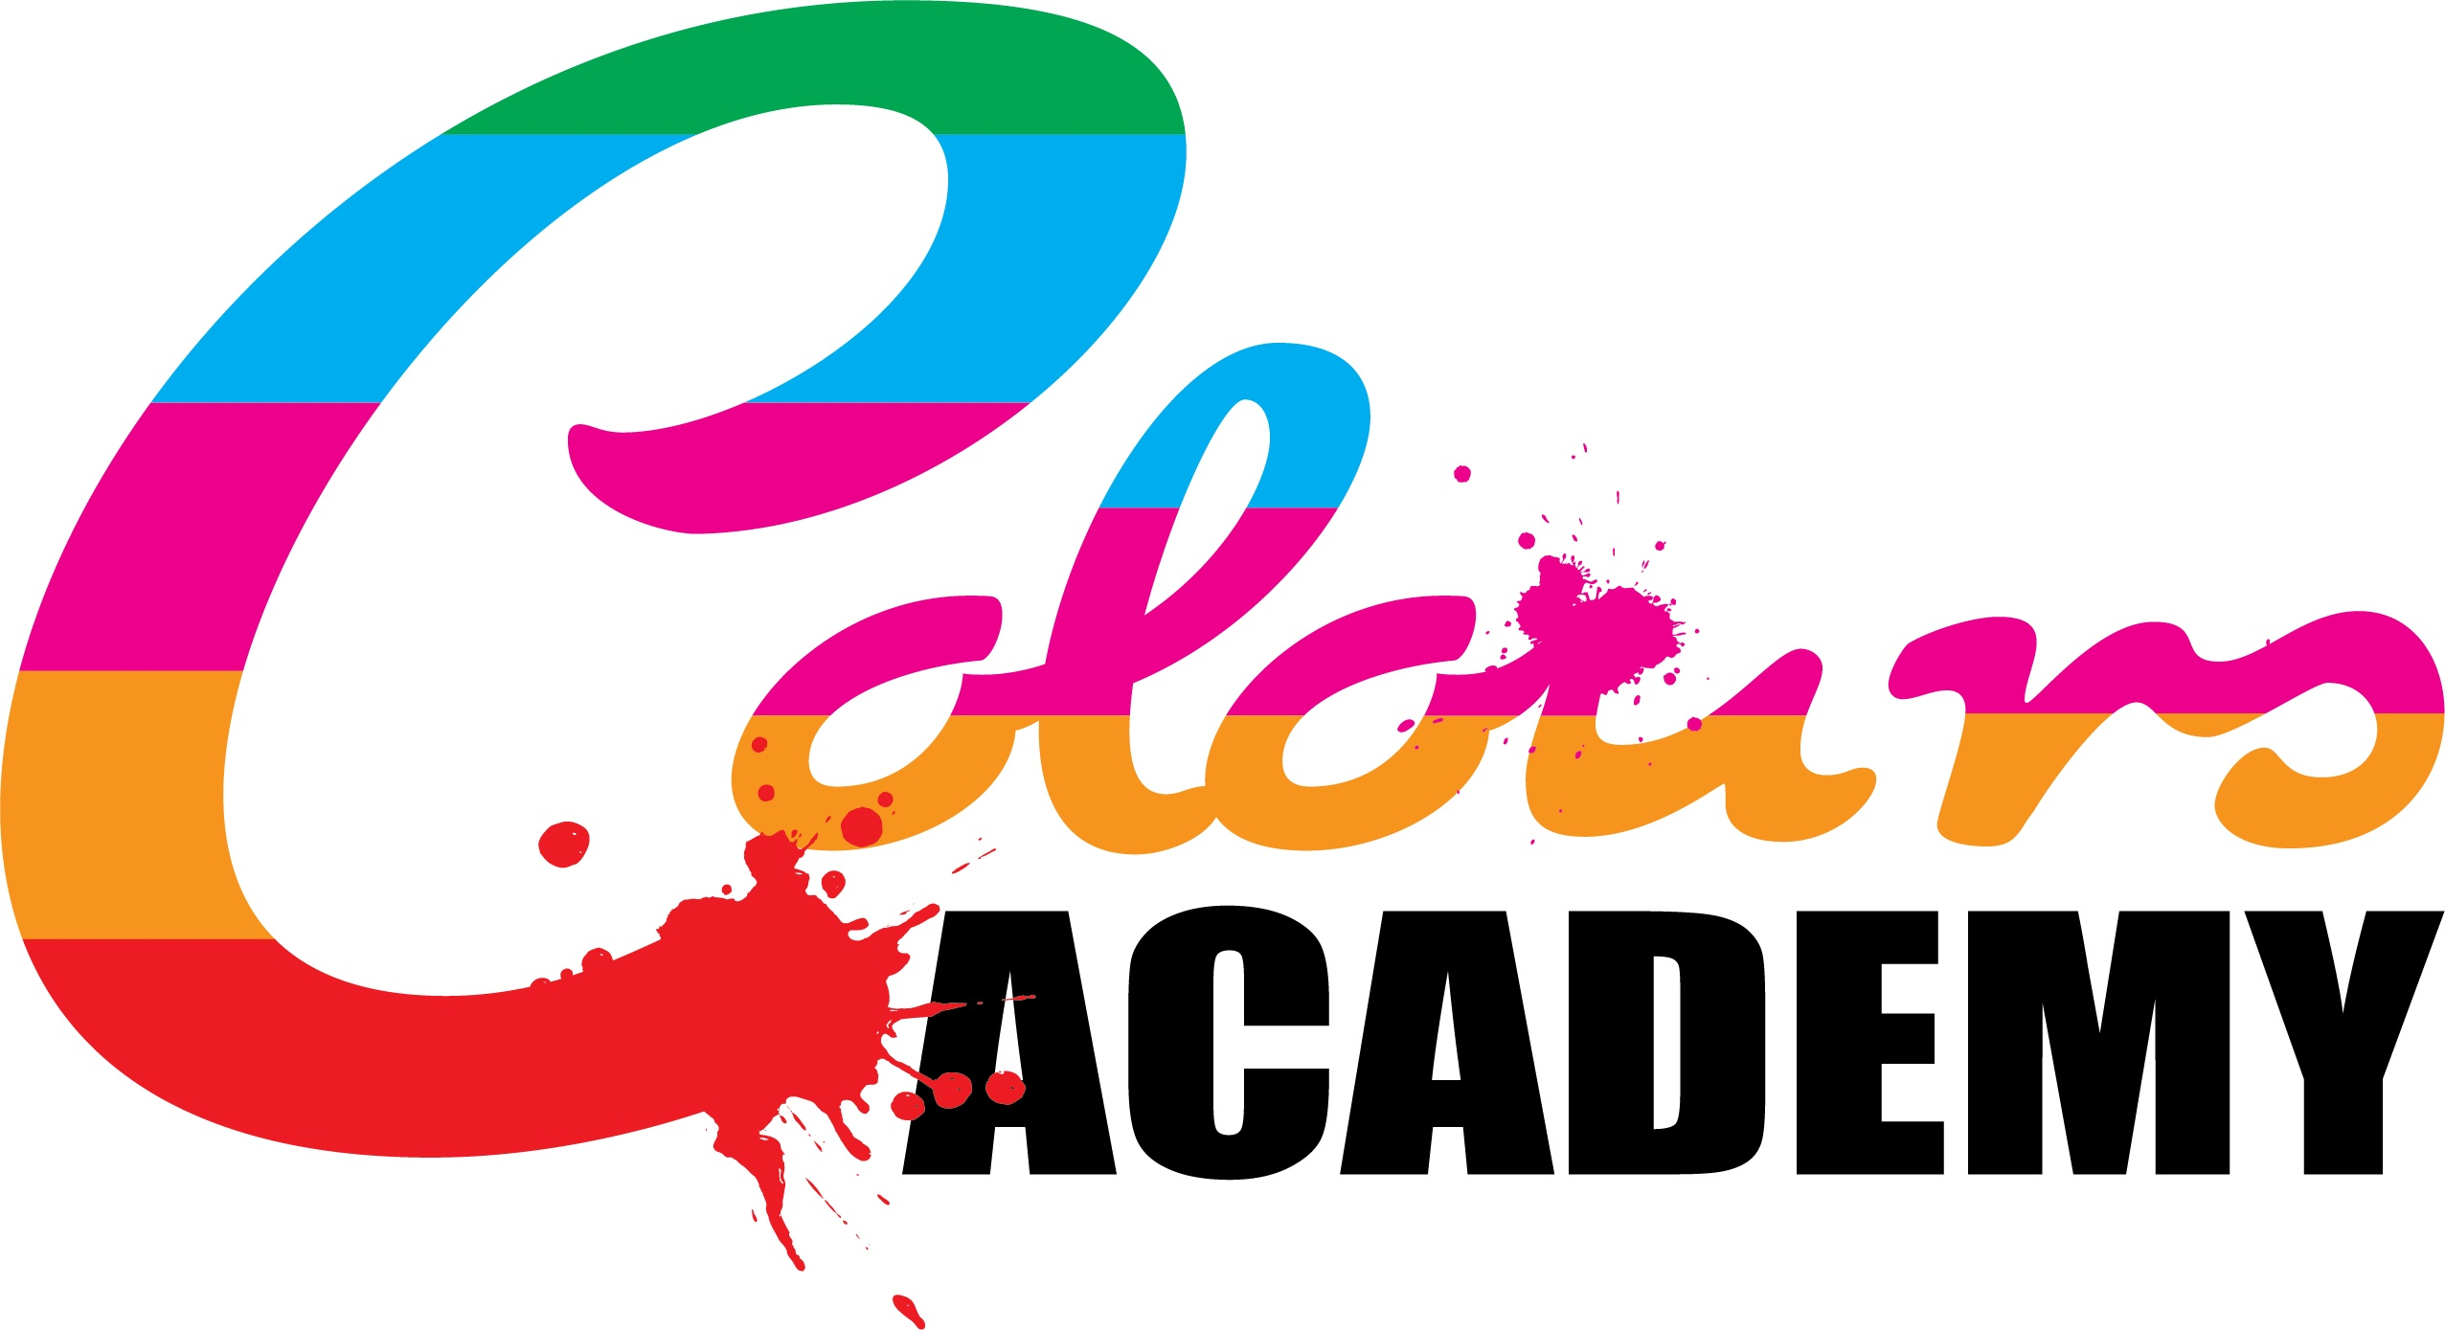

Policy Title: | Learner Appeals Policy
Approved By: | Colours Academy
Author: | Victoria Poole-Birrell
Position: | Head of Centre
Last Up-Dated: | October 2019
Review Date: | October 2020

Learner Appeals Policy

If a Further Education student wishes to make an appeal relating to an assessment, the matter should be raised initially with the relevant Assessor. The appeal should be raised orally in the first instance. This must be done within five working days of notification of the assessment decision.

The Assessor will attempt to resolve the complaint informally. He/she shall enquire into the appeal and will discuss it with the complainant, consider the information provided and advise the complainant of the decision. The decision will normally be communicated to the complainant orally, within five working days of the appeal being raised.

If, upon receipt of the decision, the complainant is still dissatisfied with the decision, he/she may progress the appeal to Stage Two.

All appeals must be made within five working days of the assessment feedback.

2.2 Stage 2

If the appeal has not been resolved at Stage One, the complainant may refer the appeal to the relevant Internal Verifier by completing the Stage Two Appeals Form. The complainant must complete the form by providing full details of the complaint and should address it to the Internal Verifier. This must be done within five working days of the end of Stage One.

The Internal Verifier will review the assessment decision with the Assessor.

The Internal Verifier will consider all the matters pertaining to the assessment and determine the outcome, usually within 20 working days of receipt of the Stage Two appeal. The result of the appeal will be communicated to all parties by completing the appeals form and copying it to all parties concerned.

2.3 Stage 3

If the complaint is not resolved to the satisfaction of the student at Stage Two, the appeal will be referred to the examining Boards Standard Verifier. This must be done within five working days of the end of Stage Two.

The Standard Verifier will consider the appeal and will be supplied with all the documentation submitted in relation to the earlier stages of the procedure.

The Standard Verifier will determine the assessment decision. Such decision will be final and will be communicated to all parties in writing. This will usually be within 20 days from receipt of the Stage Three appeal. The decision will then be binding.

Notes:

The procedure may, by agreement of the parties concerned, be used for settling a common appeal where more than one individual has the same complaint.

