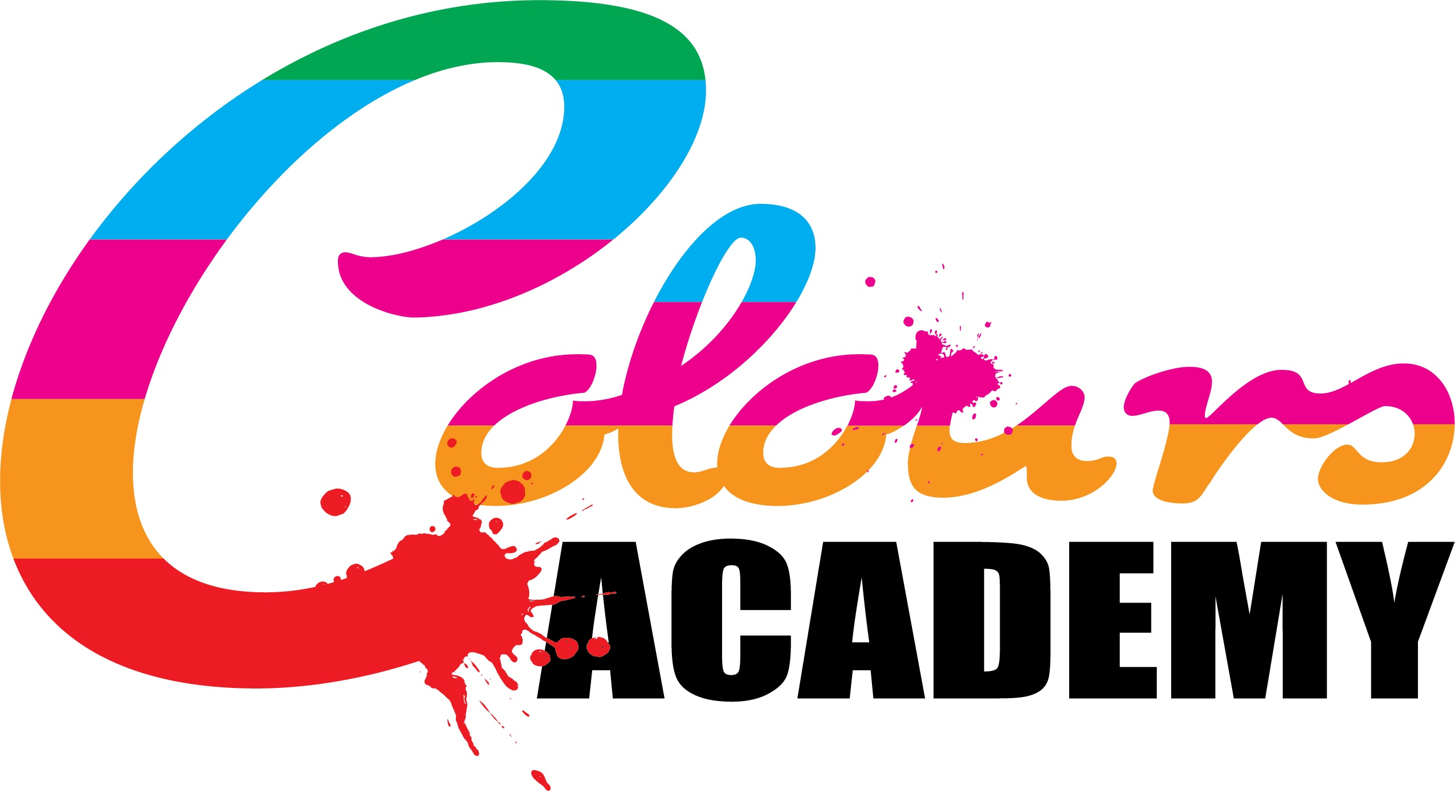
Policy Title: | Anti Bullying Policy
Policy Author: | Victoria Poole
Next Review of this policy: | February 2022

Colours Academy has created the following Anti Bullying Policy to produce a strong framework of school regulation that should be followed by school staff, teachers and the headteacher to tackle Bullying and prevent such behaviour from harming school pupils, mentally and physically.

Colours Academy aims to maintain a school community to promotes an inclusive, welcoming and diverse learning environment, that enables pupils to feel open to discuss any issues relating to bullying in and out of school and encourages happy relationships across the school premises which is respectful to both pupils and staff.

Definition of Bullying:
Bullying is unwanted negative behaviour, verbal, psychological or physical conducted, by an individual or group against another person (or persons) and which is repeated over time.

The role of staff:

Staff must own a strong leadership that aims to prevent bullying and can be informed and trained about bullying on staff training and inset days. Colours Academy aims to train and inform staff about what bullying is and the impacts it has on pupils in school. Pupils must be well supervised to prevent bullying and any incidents of bullying must be recorded, and eventually must be informed to parents. Such recording must be completed if the pupil shows signs of any other safeguarding related issue or if the pupil seems vulnerable to such harmful behaviour.

Educating pupils about bullying:

Colours Academy aims to educate pupils about bullying to prevent it from occurring amongst the school’s community. The school’s curriculum has incorporated the topic of bullying into its Physical Social Health Education sessions and implements understanding of bullying and its effects into assemblies and other together times. The curriculum aims to; ensure pupils with resilience to tackle bullying whether it be mental or physical and encourages pupils to speak out about any bullying they receive, witness or come across.

Types of bullying behaviour are should be made aware of by pupils and staff and must be taken as a form of bullying:
- Exclusion
- Gossip
- Friendship based bullying
- cyber-bullying
- homophobic bullying
- racist bullying
- bullying based on a person’s membership of the Traveller community
- bullying of those with disabilities or special educational needs.
- Posting an offensive or hurtful public message, image or statement on a social network site or other public forum where that message, image or statement can be viewed and/or repeated by other people will be regarded as bullying behaviour.

Making rude, inappropriate comments should be referred as minor bullying and should be dealt with in accordance to the Colours Academy Behaviour Policy. Such behaviour as minor bullying should involve issuing the pupil a warning, or detention.

Staff responsible for handling and reporting Bullying:

Teaching staff, Teaching Assistants and the Head teacher (Victoria Poole-Birrell)

On hearing or be informed about a case of bullying, teachers will follow the following procedure:

Staff should first hear the full statement from the individual pupil(s) who have been bullied or a witness of someone who heard the bullying take place. Staff should also discuss the following things with the individual who had committed the bullying;
- What he/she said or physically did to the pupil who was bullied
- What the impacts are of bullying, and what it could lead to
- What improvements they can make to their behaviour
- How they might go about apologising to the pupil who was bullied

Staff will collectively discuss the resolution of both the bullies behaviour and of the pupil who had received the bullying. Teachers must further inform pupil’s parents/ guardians to discuss the bullying behaviour and resolution made for both pupils if the problems persist. If the bullying shows signs of any safeguarding related issue or major behavioural downfall, then the headteacher may see it fit to contact the local policing authority.
Pupils who continue to bully other pupils or staff and do not consider the improvements that they must make to their behaviour then they may be subject to a suspension (1-4 weeks/ or until the end of half term) expulsions should be decided by the headteacher based on a record of the pupil’s behaviour.
Staff will take further disciplinary actions in accordance to the rewards and sanctions section of the Colours Academy Behaviour policy, but only if the bullying continues or becomes a result of more bullying.

Harassment
Colours Academy aims to tackle harassment as it does bullying, due to the harmful impact it can give on the school’s community and learning environment. The following types of harassment should be made aware to the school staff when coming across such forms of bullying;

- Gender
- Transgender
- Relationship status
- Family status
- Sexual orientation
- Religious beliefs
- Age
- Disability (physical and mentally)
- Race
- Membership of the traveller community

