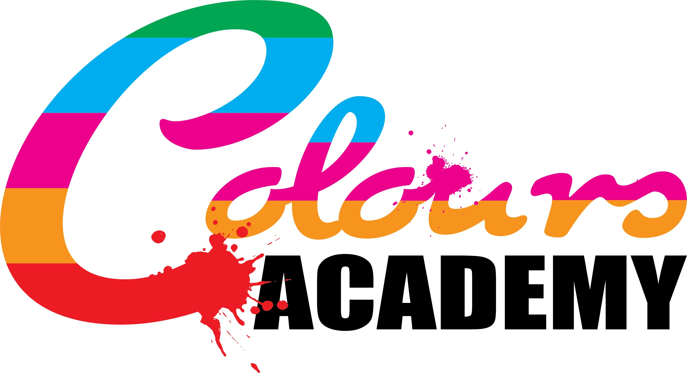

Policy Title: | Staff and Learner Malpractice Policy
Approved By: | Colours Academy
Author: | Victoria Poole-Birrell
Position: | Head of Centre
Last Up-Dated: | February 2021
Review Date: | February 2022

Malpractice Policy and Procedure
Assessment Malpractice Policy
Malpractice consists of those acts, which undermine the integrity and validity of assessment, the certification of qualifications and/or damage the authority of those responsible for conducting the assessment and certification.
Colours Academy does not tolerate actions (or attempted actions) of malpractice by:
- learners
- staff
in connection with any qualifications.
Briefing Note on Assessment Malpractice
All staff must be vigilant regarding assessment malpractice and where malpractice occurs it must be dealt with in an open and fair manner.
The policy on malpractice aims to:
- define malpractice in the context of assessment and certification for any qualifications
- set out the rights and responsibilities, with regard to malpractice, of the learner and staff.
In the interest of learners and staff, the Academy will respond effectively and openly to all requests for an investigation into an incident or a suspected incident of malpractice.
The Academy exists to provide and extend education and training amongst the communities it serves. An important aspect of academic endeavours is recognition of the effort and work of the individual learner. As such, the Academy views attempts to falsely claim the achievements of others as one’s own as a serious academic offence and has policies and procedures to deal with such actions in a fair and just manner.
Academic offences are defined as:
Cheating in an examination : Copying from the work of other learners, obtaining help from other learners in a way that contravenes the regulations for the examination, bringing into the examination any unauthorised materials, or referring during the examination to any unauthorised material, or any form of impersonation.
Plagiarism : This means copying work from any other source published, in a manner not authorised by the regulations for assessment and presenting the copied work as if it were the learner’s own work. Work presented by a learner in assessment must be the learner’s own, and where exceptions are permitted, any such exceptions must be clearly identified and the source fully acknowledged (including downloads from any internet site).
Fabrication of information : This is the presentation of any false or fabricated information, results or conclusions in any form of assessment, including practical or field work studies, oral presentations, unpublished work, and including the work of fellow learners, interviews and reports from work placements, etc.
Collusion: This is the deliberate and intentional collaboration, without official approval, between two or more learners in the development and production of work that is eventually submitted by each learner, in a substantially similar and/or identical form; and is presented by each learner to be the outcome of his or her individual efforts. Collusion also occurs where there is unauthorised co-operation between a learner and another person, in or outside of the Academy, in the preparation and production of work, which is ultimately presented, as the learner’s own.
ACTION TO BE TAKEN AT THE TIME OF ANY SUSPECTED OFFENCE
Cheating in Examinations
If an invigilator in an examination has cause to suspect any learner of cheating, for example by the discovery of unauthorised books or papers brought into the examination, these will be confiscated when discovered and any work done by the learner up to that time will be suitably annotated. The learner will, however, be allowed to complete the examination. At the end of the examination the learner may be asked for an explanation. Unless a totally satisfactory response is received, the invigilator will submit a written report to the Examinations Officer. This report will include a description of the evidence that cheating has occurred, together with details of the learner’s name, the date and time of the examination and any other relevant information. Where material is confiscated this material should be presented along with the written report. The Examinations Officer will forward this information to the examining body in line with Examination Regulations.
Plagiarism / Fabrication
Where a member of teaching staff marking an assessment, or otherwise associated with the presentation of an assessment, suspects plagiarism, fabrication or collusion of information, the matter will be reported to the relevant authority via a written report. The written report must include the appropriate details, including the nature of the alleged offence and the evidence for suspecting it. The Academy’s disciplinary process will then be followed.
Collusion
Where a member of teaching staff marking an assignment, or any piece of work associated with the assessment of units, suspects unauthorised collusion in the production of that piece of work, between two or more learners, the matter will be reported to the relevant authority; responsible for the programme via a written report. The written report should include: the nature of the alleged offence; the names of the learners suspected of colluding; and the evidence upon which the allegation is based. The Academy’s disciplinary process will then be followed.
Guidance on assessment malpractice
The Academy requires assessors in centres to ask learners to declare that their work is their own, for instance:-
For internally assessed units, assessors are responsible for checking the validity of the learner’s work. For externally assessed units, learners must provide a written declaration that the evidence is authentic and that the assessment was conducted under the requirements of the assessment specification.
The Academy will take positive steps to prevent or reduce the occurrence of learner malpractice.
These steps will include:
using the induction period and the learner handbook to inform learners of the Academy’s policy on malpractice and the penalties for attempted and actual incidents of malpractice
showing learners the appropriate formats to record cited texts and other materials or information sources including websites. Learners should not be discouraged from conducting research; indeed evidence of relevant research often contributes to the achievement of higher grades. However, the submitted work must show evidence that the learner has interpreted and synthesised appropriate information and has acknowledged any sources used.
introducing procedures for assessing work in a way that reduces or identifies malpractice, e.g. plagiarism, collusion, cheating, etc. These procedures may include:
periods of supervised sessions during which evidence for assignments/tasks/coursework is produced by the learner
altering assessment assignments/tasks/tools on a regular basis
the assessor assessing work for a single assignment/task in a single session for the complete cohort of learners
using oral questions with learners to ascertain their understanding of the concepts, application, etc within their work
assessors getting to know their learners’ styles and abilities, etc.
ensuring access controls are installed to prevent learners from accessing and using other people’s work when using networked computers.
Learner malpractice
Attempting to or actually carrying out any malpractice activity is not permitted by the Academy. The following are examples of malpractice by learners; this list is not exhaustive and other instances of malpractice may be considered by the Academy at its discretion:
plagiarism by copying and passing off, as the learner’s own, the whole or part(s) of another person’s work, including artwork, images, words, computer generated work (including Internet sources), thoughts, inventions and/or discoveries whether published or not, with or without the originator’s permission and without appropriately acknowledging the source
collusion by working collaboratively with other learners to produce work that is submitted as individual learner work. Learners should not be discouraged from teamwork, as this is an essential key skill for many sectors and subject areas, but the use of minutes, allocating tasks, agreeing outcomes, etc are an essential part of team work and this must be made clear to the learners
impersonation by pretending to be someone else in order to produce the work for another or arranging for another to take one’s place in an assessment/examination/test
fabrication of results and/or evidence
failing to abide by the instructions or advice of an assessor, a supervisor, an invigilator, or awarding body conditions in relation to the assessment/examination/test rules, regulations and security
misuse of assessment/examination material
introduction and/or use of unauthorised material contra to the requirements of supervised assessment/examination/test conditions, for example: notes, study guides, personal organisers, calculators, dictionaries (when prohibited), personal stereos, mobile phones or other similar electronic devices
obtaining, receiving, exchanging or passing on information which could be assessment/examination/test related (or the attempt to) by means of talking or written papers/notes during supervised assessment/examination/test conditions
behaving in such a way as to undermine the integrity of the assessment/examination/test
the alteration of any results document, including certificates
cheating to gain an unfair advantage.
College staff malpractice
The following are examples of malpractice by Academy staff. The list is not exhaustive and other instances of malpractice may be considered by the Academy at its discretion:
failing to keep any awarding body mark schemes secure
alteration of any awarding body mark schemes
alteration of any awarding body’s assessment and grading criteria
assisting learners in the production of work for assessment, where the support has the potential to influence the outcomes of assessment, for example where the assistance involves staff producing work for the learner
producing falsified witness statements, for example for evidence the learner has not generated
allowing evidence, which is known by the staff member not to be the learner’s own, to be included in a learner’s assignment/task/portfolio/ coursework
facilitating and allowing impersonation
misusing the conditions for special learner requirements, for example where learners are permitted support, such as an amanuensis, this is permissible up to the point where the support has the potential to influence the outcome of the assessment
failing to keep learner computer files secure
falsifying records/certificates, for example by alteration, substitution, or by fraud fraudulent certificate claims, that is claiming for a certificate prior to the learner completing all the requirements of assessment
failing to keep assessment/examination/test papers secure prior to the assessment/examination/test obtaining unauthorised access to assessment/examination/test material prior to an assessment/examination/test.
Investigating and dealing with alleged malpractice The Academy’s Disciplinary Process / Staff Disciplinary Code shall be applied. A senior manager will decide if the relevant awarding body will be contacted.
If the college discovers or suspects anyone of malpractice, it will make the individual fully aware (preferably in writing) at the earliest opportunity of the nature of the alleged malpractice and of the possible consequences should malpractice be proven. If the Academy is alleging an individual may have been involved in act of malpractice, the individual will be given the opportunity to respond (preferably in writing) to the allegations made.
The Academy will also inform such individuals of the avenues for appealing should a judgment be made against them. The Academy may have to notify the police in some cases of malpractice. It is accepted that awarding bodies may apply sanctions to the Academy.

